

Allen E. Paulson College of Engineering and Computing

Department of Electrical and Computer Engineering

EENG 4640 — EE/CpE Capstone Senior Project

EE and CpE Programs Required Course — 4 Credit Hours

Formal Project Proposal — Spring 2026
Sensor Fusion-Based Trajectory
Replanner for Industrial Robotic Arms
Sebastian Oviedo, so05798@georgiasouthern.edu, Control System Design
Elizabeth McGlone, em18976@georgiasouthern.edu, Hardware Design
Ariana Story, as51527@georgiasouthern,edu, Circuit Design
Anish Goyal, ag29340@georgiasouthern.edu, Software Design
Faculty Advisor: Dr. Mingyu Kim
Submission Date: Friday, February 06, 2026

Table of Contents
Project Summary: 3
Introduction & Problem Statement: 4
Project Block Diagram: 5
Background and Literature Review: 9
Project Description: 30
Gantt Chart/Project Breakdown and Tasks: 32
Project Goals: 40
Methodology: 41
Deliverables: 46
References: 50

Table of Figures
Figure 1 Software Block Diagram 5
Figure 2 Hardware Block Diagram 7
Figure 3 Project Details 32
Figure 4 Gantt Chart showing project completion schedule 32
Figure 5 Project tasks and completion schedule 35

Summary

Overview
Our project is a robotic arm capable of real-time obstacle-aware trajectory replanning. Conventional industrial robotic arms typically depend on passive safety mechanisms, such as safety cages or emergency stop systems, which activate only after contact has occurred. This approach can lead to safety risks and reduced productivity. Instead, we will incorporate proactive sensing and control strategies using a servo-driven robotic arm with a stepper-motor—based rotating base, along with infrared (IR) and optical sensors, to detect obstacles before contact.

Objectives
The primary objectives are to develop a low-cost, sensor-integrated robotic arm platform, enable immediate obstacle detection through multi-sensor data, and facilitate dynamic, collision-free trajectory replanning without interrupting system operation. The methodology involves mechanical modification of an existing 3D-printed robotic arm, implementation of embedded control using microcontrollers, sensor fusion to enhance environmental awareness, and development of motion models for real-time position estimation and motion adjustment.

Broader Impacts
The robot will improve operational safety in assembly lines and similar industrial, automated production environments. Additionally, the proposed design will be affordable, accessible, and scalable for broader integration. Finally, the robot prototype will come with fully reproducible, easy-to-read documentation (both on the hardware and software side) to educate general audiences on designing safe control systems.

Introduction & Problem Statement

Introduction
The motivation for this project stems from the growing need for teamwork and adaptable robotic systems that can operate safely in dynamic environments where humans or obstacles may enter the robot’s workspace. This research addresses the challenge of achieving real-time collision avoidance for robotic arms while ensuring uninterrupted operation. The main goal is to improve safety, efficiency, and availability by developing a cost-effective robotic arm system that detects obstacles and dynamically modifies its trajectory, eliminating the requirement for physical barriers or contact-based shutdown mechanisms.

Problem Statement
Robotic manipulators are extensively utilized in industrial automation, manufacturing, and research facilities. However, many existing systems lack intrinsic safety features necessary for safe human—robot interaction. In traditional industrial settings, safety is typically maintained by physical barriers or emergency stop mechanisms that activate only when an unsafe condition arises. Such methods limit system flexibility and productivity, and may still present risks even in the absence of system failures.

Project Block Diagrams
Important Note: The choice to put our Block Diagrams before our literature review section was intentional. This is because the literature review references both the hardware and software block diagrams several times, and all figure references must be in reverse chronological order.

Software Block Diagram
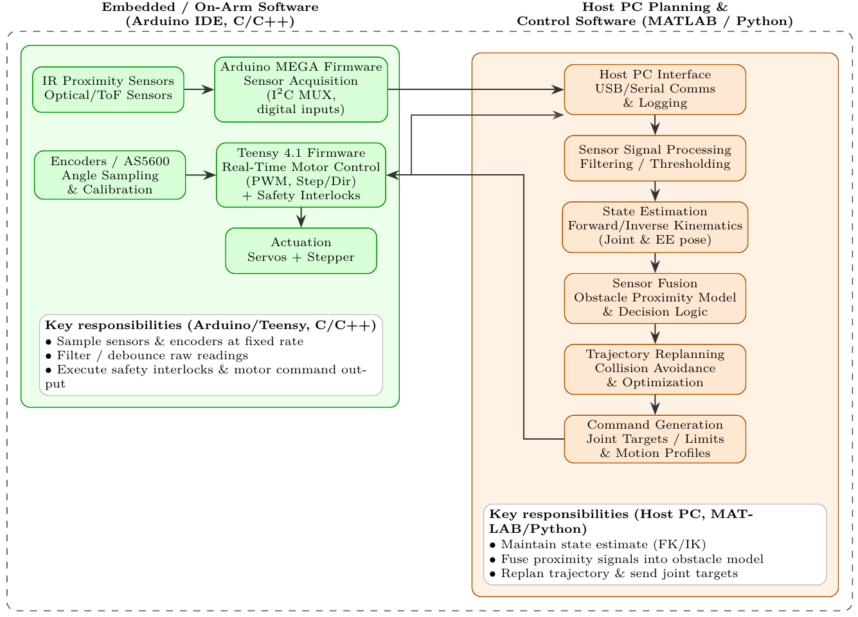
Figure 1 Software Block Diagram
Figure 1 depicts the software flow from task command to actuation. A scripted path is converted into joint-space setpoints via inverse kinematics (IK), and a time-parametrized trajectory optimizer/generator uses dynamic programming. The parallel sensor array streams range and proximity measurements that are filtered and used to estimate an obstacle's position. If an obstacle is detected within a safety threshold, the replanner modifies the active trajectory in real time (slowing down, rerouting, reacting to near-collision events) while enforcing joint and actuator constraints and maintaining compliance with the originally planned trajectory. The updated commands are then sent to the low-level motor control system for execution, and encoders ultimately update the actuators' measured positions, thereby repeating the closed-loop process.

Hardware Block Diagram
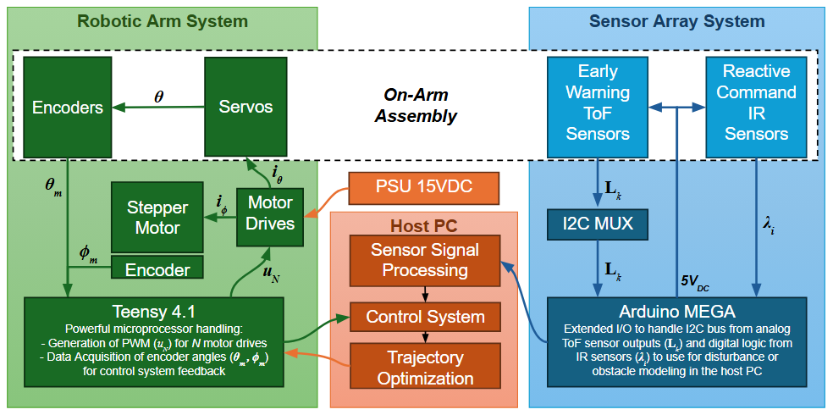
Figure 2 Hardware Block Diagram
Figure 2 depicts the hardware architecture of the proposed system. It is split between two coupled subsystems: the Robotic Arm and the Sensor Array systems. A Host PC handles all signal processing and trajectory computations (Figure 1), with the microcontrollers serving as I/O interfaces for the subsystems.
The Robotic Arm System is responsible for the motion and feedback of the controlled robotic arm. A stepper motor drives the arm’s rotation along the z-axis as it provides a full range of circular motion, and a set of servomotors provides motion along all axes according to the stepper motor’s position and their physical limits. A magnetic or optical encoder provides measured base-angle feedback (stepper), while joint positions can be extracted from the servomotors' constrained range of motion. A Teensy 4.1 is selected to manage the motors' drivers and acquire encoder data. This microcontroller was chosen due to its powerful CPU (600MHz clock speed) in comparison to other microcontrollers (for example, Arduino UNO has 16MHz).
The Sensor Array System is designed with two layers of perception: Early Warning and Reactive layers. The Early Warning System leverages Time-of-Flight sensors to measure distance and anticipate imminent collisions, enabling the hardware and software stack to compute a smoother, more evasive trajectory. The Reactive layer provides rapid obstacle cues using short-range IR sensors. An Arduino MEGA serves as the I/O hub for the sensors, selected for its extended number of I/O pins, which are necessary for scalability and testing different sensor configurations. For this project, it reads a multiplexed I2C bus to obtain ToF distances (Lk) and digital IR signals (λi).
Finally, a 15VDC PSU supplies the motor drives with the necessary higher power to operate the motors effectively, while all digital power (3.3-5V) is handled directly by the Host PC/microcontrollers.

Background and Literature Review

Hardware Platform
The project utilizes two microcontrollers to leverage their complementary strengths. An Arduino Mega 2560 is dedicated to sensor data acquisition, and a Teensy 4.1 (600 MHz ARM Cortex-M7) handles real-time motor control. This division follows a common design paradigm in lower-latency computational robotics, in which one controller handles high-rate I/O tasks while another handles precise timing for motion control. Another viable approach is the distributed model, in which all compute is offloaded to a host PC, but it would require enhanced live programming capabilities and introduce communication latency. Another promising approach for the distributed paradigm is to use an FPGA instead of a host PC; however, we do not believe programming an FPGA would be feasible at this stage.
The Arduino Mega reads the proximity sensors (via multiple analog inputs and I²C) and acts as an I/O expander (it has abundant analog pins and I²C capability), whereas the Teensy 4.1 generates the stepper motor pulses (PWM, step/dir signals) and reads joint encoders for feedback. By using the powerful Teensy for motion control, the system can achieve accurate, high-speed actuator updates, while the Mega offloads sensor polling and debouncing. This two-CPU setup avoids overloading a single microcontroller and allows for some degree of multiprogramming, since the sensors can be sampled without interrupting motor control loops.
As a team, we chose the Arduino/Teensy hardware because of our familiarity with it from previous projects, the extensive community codebase, and general ease of integration. Both the Mega and Teensy can be programmed in C/C++ (using the Arduino IDE or PlatformIO), which are both very fast, compiled languages, ensuring a unified development workflow. The Teensy 4.1, in particular, brings vastly higher performance (600 MHz, floating-point unit, etc.) compared to typical Arduino boards [1]. It essentially acts as a real-time controller "brain" on the arm, since it is capable of handling complex IK or control loops as needed. Meanwhile, the Mega may serve as a sensing hub, featuring expanded serial bus memory (unlike the Teensy's shared memory) and many I²C connections. Communication between the two controllers (and with the PC) can be done via serial or I²C lines. For example, the Mega could send processed sensor readings to the Teensy (or directly to the PC) over a serial link (Figure 2). This hardware architecture was chosen to improve reliability and responsiveness without moving to an entirely new system ( i.e., a single-board computer or different microcontroller family).

Sensor Array Configuration for Obstacle Detection
The robotic arm is outfitted with a rich sensor array to detect obstacles from all directions around its moving links. The design specifies two Time-of-Flight (ToF) distance sensors and a virtually unlimited number of IR proximity sensors distributed around the arm.

ToF Sensors
Two ToF sensors (e.g., lidar-based rangefinders) are mounted on the arm's sides to provide early warning of obstacles at a distance. These sensors can measure absolute distances by timing laser pulses and are effective at ranges of around 2—4 meters under good conditions [2][3]. Unlike simple IR reflective sensors, ToF modules (such as the ST VL53L1X) are largely independent of target color, texture, and ambient light in their distance readings [2]. Each ToF covers a certain field of view (typically ~25—30°), so by placing them on opposite sides of the arm, the system gains coverage of the environment further out to the left and right of the arm’s workspace. These act as the "eyes" that detect an approaching obstacle and allow the controller to begin adjusting the trajectory in advance (hence an early-warning function).

Infrared Proximity Sensors
Multiple IR sensors are arranged around each joint or link of the arm to create a near-field "sensing skin." The goal is to cover the full 360° around each arm segment so that any close object — from any direction — will be detected before contact. In practice, IR distance sensors (such as the Sharp GP2D series) have a shorter range (typically a few centimeters to ~80 cm or 1 m) and provide an analog voltage proportional to distance [4]. They respond quickly and are cost-effective, so many can be placed strategically around the arm. Prior research on sensor-covered robot arms has used rings of IR sensors around each link to achieve omnidirectional coverage [5]. For example, Gandhi & Cervera (2003) mounted rings of IR rangefinders (with 4—30 cm range) on a manipulator, effectively creating a proximity "skin" that detects objects within a few centimeters in real time [5]. In our design, these IR sensors serve as reactive, close-range triggers: if an object comes very near any part of the arm, an IR sensor will detect it regardless of the arm’s orientation, enabling immediate evasive action or an emergency stop.

Coverage and Placement
By combining the two sensor types, the arm gains a multi-layer perception: ToF sensors cover a longer range and give precise distance measurements (suitable for mapping obstacles in space or for trajectory planning), while IR sensors cover a short range in all directions (suitable for fast reaction and collision prevention at the last moment). The IR sensors can be mounted on the surface of the arm’s links, typically several per link (e.g., spaced evenly around the circumference) so that at least one faces any given direction [5]. The ToF units, having narrower FOV, might be placed on the forearm or base, pointing outward where coverage gaps exist — for instance, one looking to the front-left and another front-right of the arm’s reach. This ensures that, as the arm swings or extends, any obstacle in its path is detected either by the forward-looking ToF sensor slightly in advance or by the IR sensors as it approaches from the side or rear. Essentially, no blind spot should remain around each joint’s motion envelope.
To manage the many sensors, the Arduino Mega will likely use an I²C multiplexer (for the ToF modules if they share addresses) and its multiple analog input pins for the IR sensors (Figure 2) (On the Lynxmotion SSC-32 example, only 4 analog inputs were available, requiring an extra microcontroller for more than 4 IR sensors [6]—but the Arduino Mega has 16 analog inputs, allowing a large number of IR sensors to be read directly). The Mega can poll each IR sensor and apply any filtering (averaging, debouncing) to avoid noise-induced false triggers. It can also read the ToF sensors via I²C and perhaps set thresholds (many ToF sensors support programmable interrupt thresholds for a given distance [7]). The data (distances or binary obstacle flags) is then sent to the host PC and/or the Teensy in real time.

Sensor Performance
The chosen Sharp IR sensors (GP2Y0A family or similar) typically measure distances in a specific range (some models 10—80 cm, others 4—30 cm) [4][8]. They have non-linear response curves and can be influenced by the object’s surface (though modern ones mitigate color sensitivity). The ToF sensors (like VL53L1X) give precise distance readings (to 1 mm resolution) up to a few meters, but require clear line-of-sight and have a relatively small field-of-view (~15—27°) [3][9]. In practice, the IR and ToF would need to be properly calibrated so that their readings are interpreted consistently (e.g., by aligning their detection criteria at overlapping distances). The combination is powerful: as one forum discussion noted, ultrasonic sensors were historically suggested to complement IR for longer range [10][11], but compact ToF lidar now offers that extended range (several meters) with better resolution. Thus, the two ToFs will fill the gap beyond the IR’s reach (which is at most ~80 cm in our case), enabling obstacle detection from a few centimeters all the way to a few meters around the arm.

Obstacle Avoidance Strategy and Trajectory Adjustment

General Approach
Given the sensor inputs, the robotic arm’s controller must determine how to adjust its movements in real time to avoid collisions. The team is open-minded (“anything, to be honest”) about the specific avoidance algorithm, so both simple reactive strategies and more sophisticated planning methods are on the table. At minimum, the system will implement safety interlocks: if an IR sensor detects an object extremely close, the arm should immediately pause or stop to prevent a crash (this is a reflexive reaction). Beyond that, for more graceful avoidance, the controller can replan the arm's trajectory on the fly when a mid-range obstacle is detected by the ToF sensors.

Reactive Methods
One straightforward method is a threshold-based response. For example, if a sensor on a particular side of the arm detects an obstacle within a certain distance, the controller could slow down or limit motion in that direction. This is analogous to a basic obstacle avoidance in mobile robots, where a sensor trigger causes the robot to turn or stop. On a robot arm, this could mean: if an IR on the left side of a link triggers, the joint should perhaps halt or move slightly back to the right until the obstacle clears. Such hard-coded reactions need careful tuning to avoid jerky motion, but they are fast. They essentially create a “virtual bumper” around the arm — any intrusion triggers immediate evasive action. This method ensures reliability (it is less likely to collide when thresholds are conservative) but can lead to inefficient or stuck motions if multiple sensors trigger (the classic problem of potential oscillations or deadlocks).

Path Replanning
A more global approach is to actively plan a new path for the end-effector when an obstacle is sensed, so that the target can still be reached without collision. This involves the host PC computing a modified set of joint angles or waypoints that steer around the obstacle. One way is to use the concept of artificial potential fields (APF), where the obstacle generates a repulsive “force” on the arm’s configuration. APF methods treat the goal as an attractive potential and obstacles as repulsive potentials [12]. The controller then moves the arm along the gradient-descent direction of the combined potential field. These methods are computationally light and work in real time, but one must watch out for local minima (where the arm could get “stuck” between obstacles) [13][14]. For a single arm and relatively sparse obstacles, an APF-based avoidance could be effective. In fact, many real-time manipulator-avoidance systems have successfully used potential fields to generate on-the-fly detours around obstacles [12].
Another strategy is to use a search-based planner: for instance, run a simplified path-planning algorithm (such as RRT or PRM) when an obstacle is detected to find a new collision-free joint trajectory. However, those can be too slow for dynamic avoidance unless heavily optimized. A middle ground is to use model predictive control (MPC) or other optimization methods; for example, a recent approach combined MPC with an improved APF to avoid obstacles smoothly while tracking a target path [15][16]. The idea would be to continuously re-optimize the arm’s trajectory (over a short horizon) to minimize deviation from the target while keeping a safe distance from sensed obstacles. This requires more processing, but Teensy 4.1 or a PC can handle moderate computations at reasonable rates, given the 6-DOF arm.

Learning-Based Methods
Although not part of the current plan, it’s worth noting that researchers have explored machine learning to address arm collision avoidance. For example, one prototype used reinforcement learning to map readings from a ring of IR sensors into joint motion commands [5]. The arm essentially learned, through trial and error, to avoid obstacles while still reaching its goal. The learning approach can, in theory, discover clever avoidance maneuvers and handle complex scenarios (like moving obstacles or unpredictable human interference). The downside is the need for training data and the difficulty in guaranteeing safety during learning. In our context, we will likely first pursue more deterministic methods (such as thresholding or replanning), but learning is an interesting avenue if we collect sufficient sensor data during operation.

Execution of Avoidance
Once the high-level algorithm (reactive or planned) decides on a course of action, the microcontrollers and motors execute it. For instance, if a new collision-free joint trajectory is computed by the PC (perhaps using IK for intermediate waypoints), it can send a stream of new joint angles or target positions to the Teensy 4.1. The Teensy will then smoothly interpolate those values (while applying acceleration limits) to move the servos/steppers. If instead a simple reactive rule is triggered (say “stop Joint 2 movement”), that command can be issued immediately to the motor controller on Teensy as well. The safety interlocks on the Teensy firmware will also play a role: if a very close obstacle is detected, the Teensy can override and zero the motor commands instantaneously for safety (Figure 1). This layered approach (a reflex stop at the microcontroller level and smarter avoidance at the PC level) ensures both a fast response and intelligent behavior.

Software Architecture and Implementation (Python vs. Simulink)

Custom Python Control on Host PC
Instead of using ROS or MATLAB’s robotics toolkit, the plan is to write a custom control program in Python that runs on a PC/laptop. This host PC software will maintain the robot’s state and execute the high-level algorithms discussed. In practice, the program will continuously perform a cycle of: read sensor data from the microcontrollers (via USB serial), update the arm’s state (using forward kinematics to compute the end-effector position from the latest joint angles, and perhaps building a simple occupancy model of nearby obstacles), then decide on control actions (using logic or planning to adjust the trajectory), and finally send commands back to the microcontrollers (new joint angle targets, velocity limits, etc.) (Figure 1). Using Python for this offers flexibility and rapid development — we can easily integrate libraries for math, optimization, or even visualization of the arm’s configuration. Key components of the Python software will most likely include the following:

Inverse Kinematics and Kinematic Modeling
The arm’s geometric model (link lengths, etc.) will be coded to support FK and IK. There are libraries available, such as IKPy and the Robotics Toolbox for Python, that provide convenient IK solvers and support Denavit-Hartenberg models [17] [18]. For example, IKPy can compute the IK for a desired end-effector target frame given a defined link chain [19]. Alternatively, one can use a numeric IK method such as the Jacobian transpose or Levenberg-Marquardt, both of which are built into Simulink, to obtain joint angles that avoid obstacles. The Robotics Toolbox for Python [20] similarly allows the definition of a serial-link manipulator and the computation of FK/IK, and it includes trajectory generation and even a simple simulator called Swift. In our case, since we have a physical robot, we’ll use these tools primarily for calculations and perhaps for some sanity-checking during simulation. Python’s NumPy will be essential for linear algebra in the IK calculations.

Sensor Fusion and Filtering
Raw data from multiple sensors must be fused and filtered to produce a coherent picture. The Python code can take the distance readings from the two ToF sensors and, for instance, determine if an obstacle is on the left or right side based on which sensor sees it first, possibly triangulating an approximate position. The numerous IR sensor triggers might be fused into a simpler representation (e.g., an array of boolean flags for each zone around the arm). Some filtering (such as debouncing IR signals or averaging the ToF distance over a few readings to reduce noise) will likely be performed on the microcontroller, but additional smoothing or thresholding logic can be applied in Python. For example, the host software might ignore a single brief spike from an IR sensor unless it persists, to avoid false alarms.

Collision Detection Logic
The PC program will maintain an obstacle-proximity model. This could be as simple as: for each arm link, check the reported distance to the nearest obstacle and compare it to a safety threshold. Or a bit more involved: construct a small occupancy grid or mapping of the workspace around the arm (perhaps in polar coordinates around each joint). Since we do not have a full 3D vision system, the model might not know exact shapes, but it can flag regions to avoid. The decision logic then interprets this model to decide if the current trajectory will intersect an obstacle. For example, if the arm is moving straight to a target and a new obstacle is detected in its path, the logic can trigger a replanning event.

Trajectory Replanning and Optimization
Implementing a real-time replanner in Python is feasible given today’s computing power and the arm’s relatively slow movement speed. A simple approach is to use intermediate waypoints: if an obstacle is detected ahead, create a waypoint that diverts the end-effector around the obstacle (to the side or above it) before proceeding to the final target. Optimization algorithms (such as simulated annealing or a greedy search) could adjust that waypoint to minimize additional path length. Another approach is to solve a constrained optimization problem: minimize time or path deviation, subject to the constraint that the distance to the obstacle exceeds the safety margin. Python libraries like SciPy.optimize can handle small nonlinear optimization problems if needed. In more advanced cases, if the arm has a known workspace model, one could integrate a library like OMPL (Open Motion Planning Library) via bindings, but that might be overkill. The emphasis will be on maintaining a safe distance and smooth motion. The trajectory planning will also ensure that joint and velocity/acceleration limits are not violated (we must avoid commanding the arm to do something it physically cannot do). The output of this replanning stage is a new set of joint targets or a modified trajectory profile, which is then sent to the microcontrollers.

Host-PC to MCU Communication
The Python program will interface with the Arduino Mega and Teensy, likely over USB serial links. For example, the Teensy 4.1 can enumerate as a USB serial (or a device like HID), and the Arduino Mega via its programming USB (Serial). We could assign one COM port to sensor data and the other to motor commands, or have one microcontroller relay data to the other. A clear protocol will be defined—e.g., the Mega might send a stream of sensor readings at, say, 50 Hz, and the PC sends back updated joint angle setpoints or velocity scaling commands whenever needed (perhaps also ~50 Hz). Logging could also be done on the PC side, recording sensor values and commanded positions for analysis.

Embedded Firmware (Arduino/Teensy)
On the microcontroller side, the software (written in C/C++ for the Arduino framework) complements the PC software. The Arduino Mega firmware will sample sensors at a fixed rate (possibly using interrupts or ADC reads in a loop) and format the data for transmission (Figure 1). It might use an I²C multiplexer to cycle through the ToF sensors’ readings, and do analog reads for each IR. Simple filtering, like moving averages or thresholding (to convert an analog distance to a binary “too close” flag), can reduce the data volume — e.g., only send a message when an IR sensor crosses its threshold. The Teensy 4.1 firmware will handle the low-level motor control: reading encoder values (for closed-loop feedback if applicable) and generating PWM/step signals for the motor drivers at the required frequency. The Teensy will likely run a control loop at a few kHz that reads the current joint angles (from encoders) and compares them with target angles (from the PC or an internal trajectory). It will apply a PID or similar control to smoothly drive the motors. Crucially, the Teensy firmware will also implement safety interlocks: if it receives a command from the Mega or PC indicating a critical obstacle (or if its own encoder logic detects an unexpected resistance), it can override and stop motion to prevent damage.
Since ROS is not being used, all coordination is manual: for example, the Mega might simply stream sensor values, and the PC must parse them, determine which sensor corresponds to which link, and what that means for avoidance. Likewise, without MATLAB’s Simulink running the show, the team will code the logic flows themselves. This is more work, but it also means the system is lightweight and runs in real time without the overhead of ROS nodes or the Simulink Real-Time Toolkit.

MATLAB/Simulink Alternative
We included this for completeness, though it likely won’t be used in the final implementation. If we were to use MATLAB and Simulink as originally proposed, the workflow would look somewhat different. We could import the arm’s CAD model (STL files for each link) into Simulink’s Simscape Multibody environment to simulate the robot’s kinematics and dynamics [21][22]. MathWorks provides tools such as the Simscape Multibody Link plugin for SolidWorks/Inventor, which can export an assembly as an XML file and its associated STL geometry. Using the smimport function, the model can be imported into Simulink, automatically creating blocks for joints and bodies [21][23]. This would allow visualization of the arm and even the obstacles in 3D space. In Simulink, one could then design a control system block diagram. For example, using Simulink blocks (or Stateflow) to implement a state machine for obstacle avoidance: a block for sensor processing (reading inputs, possibly via Arduino support packages), a block for computing IK (MATLAB has a Robotics Toolbox too, which may be used in conjunction with Simulink), and blocks for motion planning (trajectory generation). The advantages of this route include a high-fidelity simulation (you can test avoidance strategies in a virtual environment before deployment) and the ability to automatically generate C code from the Simulink model (using MATLAB Coder or Simulink Coder) to run on microcontrollers. In fact, MATLAB’s Arduino and Teensy support (Teensy via Simulink Embedded coder support package) could potentially deploy the control algorithm directly to those boards. However, the disadvantages were complexity and the steep learning curve, so we decided to abandon ROS/Matlab in favor of direct Python control. Nevertheless, there are plenty of resources on using Simulink for robotic arms for IK calculations (for instance, MathWorks has tutorials on importing CAD models and building controllers in Simulink [24][25], and examples in which a 6-DOF arm’s STL model is used in Simscape to simulate pick-and-place tasks), and the procedure from some of these resources may be used in a more generalized sense for the Python implementation.
To summarize, the software system is split between real-time low-level code in C/C++ on the microcontrollers (for fast, deterministic execution of sensing and actuation) and high-level logic in Python on a PC (for ease of development and powerful computation for kinematics and planning). This architecture, illustrated in Figure 1, gives us the best of both worlds: the PC can do heavy calculations (like matrix ops for IK or running an optimization for a new path) that would be difficult to implement on an 8-bit Arduino, and the microcontrollers ensure that motor control signals and safety responses are rock-solid in real time.

Evaluation Metrics for Reliability, Accuracy, and Speed of Obstacle Avoidance
To validate the system, we need to define clear benchmarking metrics that quantify how well the robotic arm’s obstacle avoidance performs. This includes how reliable it is (safety and consistency), how accurate it is in achieving its goals, and how it affects the speed or efficiency of operation. After researching existing practices and considering the nature of our project, here are some key metrics and testing procedures:

Collision Avoidance Success Rate
This is a direct measure of reliability and safety. We will run the arm through many trials where an obstacle is introduced in its path and see if the arm successfully avoids it without any contact. The success rate (percentage of trials with no collision) is a simple metric—ideally 100% for a well-functioning system. In practice, we might count a run as failure if the arm or its payload touches the obstacle or comes within a dangerously small distance (e.g. <1 cm). This metric can be further detailed as Mean Time Between Failures in continuous operation, if the arm is running extended periods: essentially, how often a collision or emergency stop occurs. A high success rate (or long time between incidents) indicates strong reliability.

Minimum Distance to Obstacle (Safety Margin)
In each avoidance trial, we can record the closest distance that occurred between any part of the arm and the obstacle. This speaks to both reliability and accuracy of avoidance. We want this minimum distance to always be above some safety threshold (say 5 cm or whatever is deemed safe for the context). If the system is accurately sensing and avoiding, it should maintain a buffer. Variations in this minimum distance across trials will tell us how consistent (reliable) the avoidance behavior is. For instance, if one time it barely squeaks by at 0.5 cm and another time stays 10 cm away, that inconsistency might be an issue to address in the control logic. We could compute an average minimum distance and a standard deviation. We expect the IR sensors (with ~4 cm range min) to ensure a few centimeters gap at least, and we can adjust thresholds to achieve a desired nominal clearance.

Task Completion Accuracy
Even while avoiding obstacles, the arm still has a task (e.g., reach a target position or follow a trajectory). We should measure end-position error, i.e., how close the arm gets to the intended goal despite the detour. For example, if the target was to pick an object at point (x,y,z), after avoiding an obstacle, does the end-effector still reach that point within acceptable error? Robot accuracy is typically defined as the difference between the commanded end pose and the achieved end pose [26]. We can use something like mean absolute error or max error in the final position across trials [27][28]. Ideally, the avoidance shouldn’t compromise positioning too much — perhaps a few millimeters of error if the path was altered. If too inaccurate, it means the arm may fail at its intended task (e.g. missing a pick-up after skirting an obstacle).

Path Deviation / Efficiency Loss
Avoiding obstacles often means a longer or more complex path. A good metric for speed/efficiency is to compare the trajectory's path length or execution time with an obstacle to that without an obstacle. For instance, trajectory length increase (%): if the arm normally moves in a straight line of 0.5 m, but with an obstacle, it has to move 0.7 m around it, that’s a 40% increase. Similarly, the completion time might increase from 2 seconds to 3 seconds due to slowing or detours. We can measure the “job execution time” for the task, which is a standard performance indicator in robotics [29]. This metric addresses the speed: how much does obstacle avoidance slow down the operation? We expect some slowdown, but a well-optimized system will minimize it. We may run a variety of scenarios (obstacles at different locations) and log the time taken to complete the move and compare it to obstacle-free time. This will give us an average delay caused by avoidance.

Smoothness of Motion (Calculating Jerk and Stops)
A qualitative but important aspect is whether the arm moves smoothly while avoiding or if it jerks/stutters (which could affect both speed and mechanical wear). We can quantify smoothness by looking at the joint velocity and acceleration profiles during avoidance. Particularly, measuring jerk (rate of acceleration change) can indicate how abrupt the motions are. In an ideal scenario, the controller should slow down or change course gently rather than in a start-stop manner. If we log joint velocities at high frequency, we can compute the peak jerk for each joint. Large spikes in jerk mean sudden changes (e.g., an emergency stop when an obstacle appears at the last second) [26][27]. If our avoidance algorithm is working nicely, we hope to see lower jerk values, indicating a smoother avoidance maneuver. Some literature suggests keeping jerk low improves safety and reduces wear [25][27]. We can compare jerk profiles between runs with no obstacles vs with obstacles — an effective avoidance controller might slightly increase jerk (since it’s responding), but not excessively so [25][29].

Controller Response Time
When an obstacle is introduced, how quickly does the system react? This can be measured as the latency from obstacle detection to action. For instance, if an obstacle jumps in front of the arm, does it take 100 ms for the arm to start decelerating, or 500 ms? We can test this by introducing an obstacle (like moving a piece of cardboard into the arm’s path) at known times and recording when the arm changed its trajectory or stopped. The Teensy’s fast loop should allow very quick responses (on the order of a few milliseconds for reflex stop after IR trigger), but the overall system response (including communication to PC if needed) might be longer. If using purely on-board reflex (stop instantly on IR trigger), then response could be ~5—10 ms. If waiting for PC to replan, maybe ~50 ms. We want to ensure the delay is short enough to be safe at the speeds the arm moves. A metric here could be response delay in milliseconds, averaged over tests. Shorter is better.

Repeatability and Consistency
Like industrial robot evaluations, we can look at repeatability—if the same scenario is run multiple times, does the arm behave the same way? We might place an obstacle in a fixed position and command the same move 10 times, then see how much variation there is in the arm’s path and end position. If the system is consistent, the paths should overlap closely and end positions cluster within a small region. Repeatability is often considered separate from accuracy; it reflects the robot’s reliability in reproducing motions [30]. Here, it would show the reliability of avoidance behavior. High repeatability (low scatter in outcomes) even in the presence of obstacles would be desirable — it means the control strategy is deterministic and stable, not random or erratic.

Data Collection Procedure
To gather these metrics, a structured experiment plan is needed. One proposed procedure is:
- Define a set of standard test scenarios. For example: (A) an obstacle placed at a mid-point between the arm’s start and goal (to test going around it), (B) an obstacle suddenly introduced from the side during motion (to test reflexes), (C) no obstacle (baseline), (D) multiple obstacles if possible (to test more complex avoidance). The obstacle could be a lightweight object or a piece of foam for safety, and its position can be measured or marked
- Use a motion capture system or external measurement if available, to accurately track the arm and obstacle positions. If not, use the arm’s encoders and known geometry to reconstruct the path, and maybe manually measure final distances. - Run each scenario multiple times (e.g., 5—10 trials) and record all relevant data: sensor readings over time, joint angles over time, whether a collision occurred, etc. Logging on the PC will facilitate this. We’ll also log timestamps for events (like “obstacle detected” and “avoidance start”).
- For scenario (A), we can analyze how the trajectory differed from the straight-line path: visualize the path or compute path length.
- For (B), we check the reaction time from introduction to stop/re-route.
- Compute the metrics: success rate = (collisions avoided) / (total trials) * 100%; average min distance; average completion time vs baseline; and so on, as described above.
- Gather some qualitative observations:
- Did the arm ever oscillate or get stuck trying to avoid? (This might indicate a local minimum issue in a potential field approach, for example.)
- Did the sensors ever miss an obstacle (false negative) or trigger too much (false positives causing unnecessary stops)?
By analyzing these metrics, it becomes possible to identify bottlenecks and weaknesses. For instance, if the success rate is high but the path length is consistently much longer, maybe the algorithm is too conservative (always taking a wide detour—safe but slow). Alternatively, if the minimum distance sometimes dips very low, that might mean our threshold/timing is marginal.

Industrial Robot Safety Standards/Thresholds
The ISO 10218 series is the foundational international safety standard for industrial robots and robotic systems, establishing the core safety requirements that govern acceptable design, integration, and operational practices. ISO 10218-1 specifies safety requirements for industrial robots as standalone machines, emphasizing risk reduction through mechanical design, control system reliability, and protective measures that minimize hazards associated with robot motion and failure modes [4]. ISO 10218-2 complements this by addressing system-level safety requirements, focusing on robot integration into industrial cells and providing guidelines for installation, operation, maintenance, and lifecycle considerations, including commissioning and decommissioning [5].
In the United States, ANSI/A3 R15.06-2025 is the primary national standard for industrial robot safety, incorporating and expanding international requirements. This standard aligns with the ISO 10218 series and adapts its requirements to the U.S. regulatory and industrial context, providing a comprehensive framework for risk assessment, safeguarding, and system integration [6]. ANSI/A3 R15.06 emphasizes the importance of proactive safety strategies, including reliable control systems and protective measures, to reduce risk in human-occupied environments. The robotic arm developed in this project is a low-cost educational prototype, and its design principles align conceptually with the safety objectives outlined in ISO 10218 and ANSI/A3 R15.06.
It’s also worth noting that formal standards for collaborative robot safety (like ISO 10218-1 and ISO/TS 15066) define many limitations of robotic locomotion (such as the allowable force or speed when near humans)—this is mostly due to electrical/control system safety hazards (i.e., What if the robot suddenly loses power?) This limitation on movement places some “fault tolerance” in the bot such that no single action that the robot takes in the vicinity of a human would ever be fatal. While our metrics are more basic, we believe they align with the spirit of keeping the robot at safe distances and speeds around obstacles (which we would consider proxies for humans or equipment in our experimentation). If needed, we could also measure force upon collision (if a collision with a force sensor can be measured without damage) to ensure it’s below safety limits, but ideally, our system would avoid contact altogether.

Project Description
This project aims to design and implement a robotic arm that detects nearby obstacles and dynamically adjusts its trajectory to prevent collisions during operation. The project scope encompasses mechanical modifications to a 3D-printed robotic arm, integration of servo motors for joint actuation, incorporation of a stepper motor for base rotation, and development of real-time sensing and control algorithms using microcontrollers. The system is designed to demonstrate proactive safety behavior while maintaining continuous operation in environments with humans or obstacles.
The proposed solution employs a five-degree-of-freedom robotic arm, extended mechanically to enhance reach and more closely resemble industrial manipulator proportions. A stepper motor at the base provides precise rotational control. IR and optical proximity sensors are positioned to monitor the robot’s workspace. Sensor data are fused to estimate obstacle proximity, while a kinematic model estimates joint and end-effector positions in real time. Upon detecting an obstacle within a predefined safety threshold, the system adjusts its trajectory to avoid collision without necessitating a complete system halt.
This project emphasizes affordability, modularity, and safety-oriented design. Using low-cost components, open-source development tools, and additive manufacturing, the project demonstrates that core safety principles from industrial robotics can be implemented in an academic and educational context. The system serves as a proof-of-concept platform for human-aware robotic manipulation and provides a foundation for future enhancements, such as advanced sensor fusion, higher-degree-of-freedom systems, and machine-learning-based trajectory optimization.
The project is feasible because it uses commercially available components, existing open-source robotic arm designs, and established control methodologies. However, the project faces several constraints. Technical constraints include the limited computational resources of microcontrollers, sensor noise, and the positional resolution of hobby-grade servo motors. Time is also a major constraint, as the design, implementation, integration, and testing of the robotic arm must be completed within a single academic semester (approximately four months). This time limit requires careful scope management, incremental testing, and prioritization of core functionality to ensure a successful system demonstration within the allotted timeframe.

Gantt Chart/Project Breakdown and Tasks:

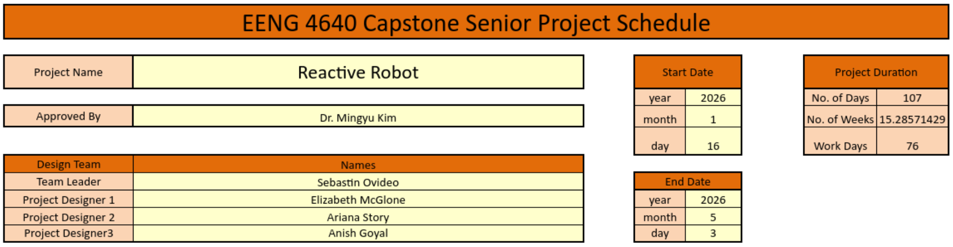
Gantt Chart

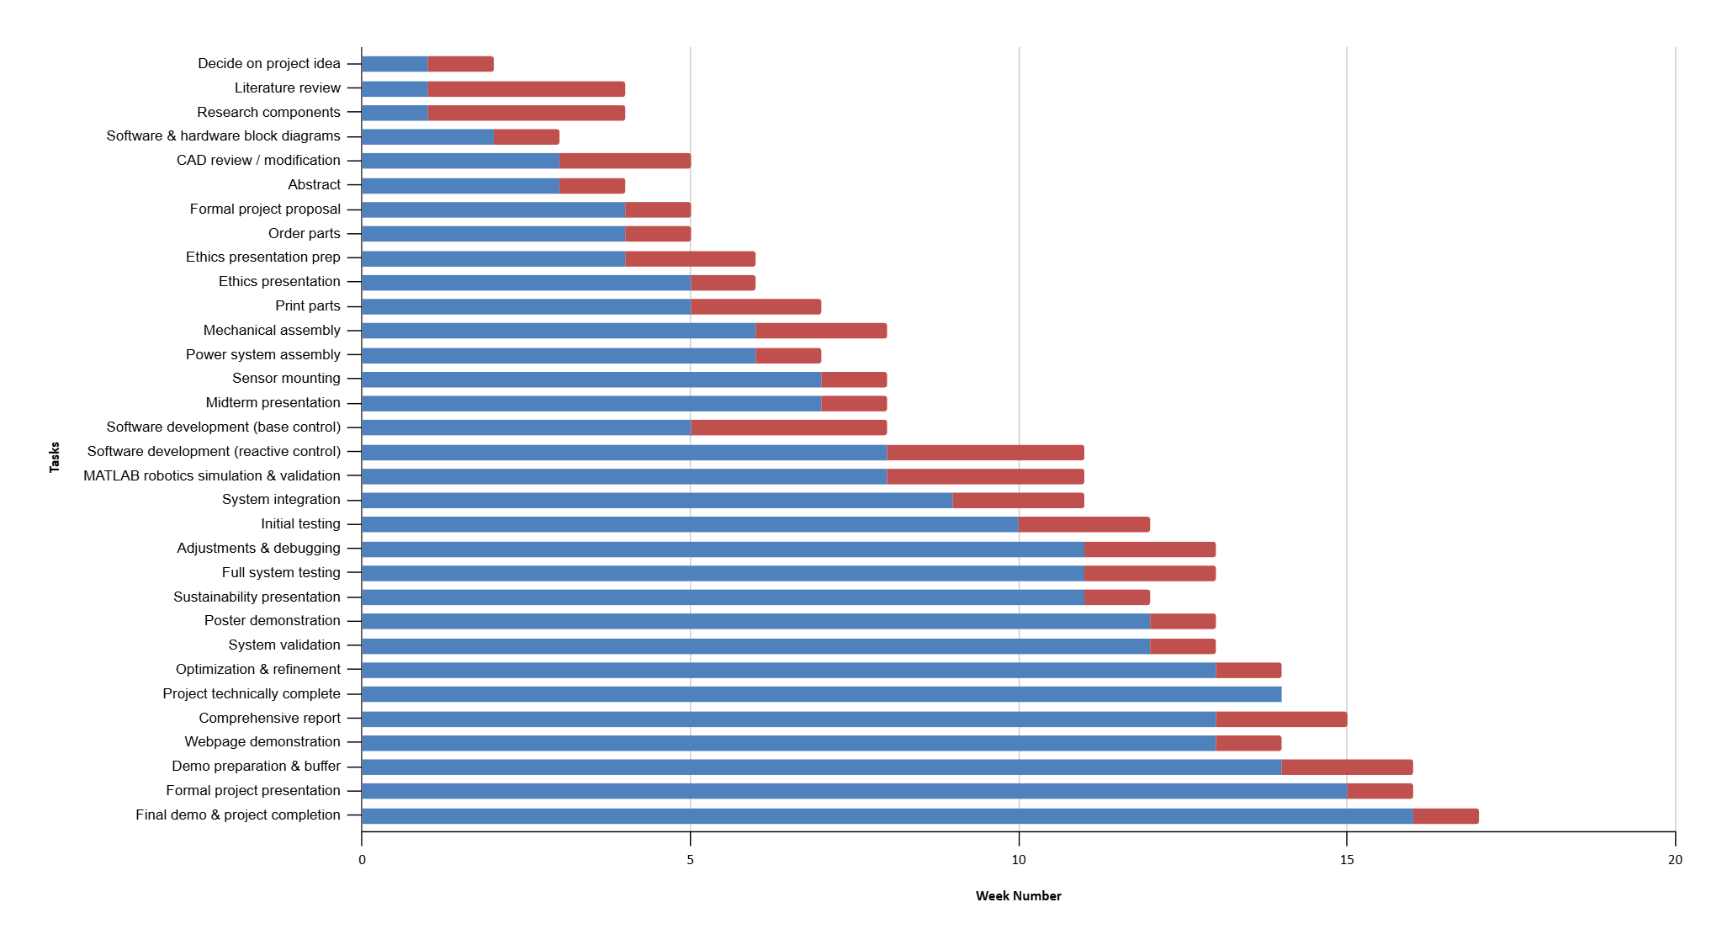
Figure 3 Project Details

Figure 4 Gantt Chart showing project completion schedule

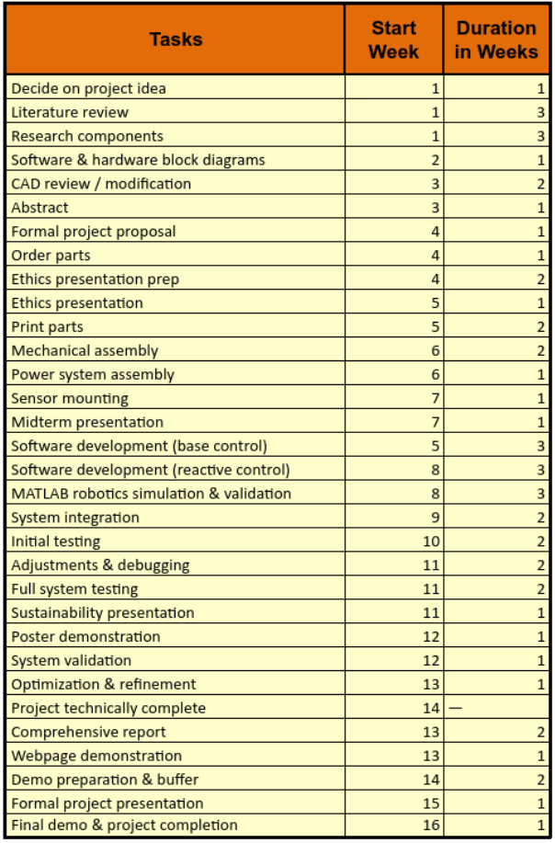

Figure 5 Project tasks and completion schedule

Project Breakdown and Tasks
The project is divided into structured phases aligned with the Gantt chart (Figures 4 and 5). Each phase includes specific tasks, estimated completion timelines, and clearly assigned responsibilities based on team member roles to ensure an even distribution of work throughout the semester.

Phase 1: Background Research and Project Definition (Weeks 1—3)
Objectives: Establish technical background, define system requirements, and select components.
Tasks and Responsibilities:
- Project idea selection (Week 1): All team members
- Literature review (Weeks 1—3):
  - Control strategies, sensor fusion, and collision avoidance theory — Sebastian
  - Mechanical design concepts and robotic arm architectures — Elizabeth
  - Circuit design fundamentals, power distribution, and sensor interfacing — Ariana
  - Software architectures, IK, and simulation tools — Anish
- Component research (Weeks 1—3):
  - Mechanical components, motors, and structural materials — Elizabeth
  - Power electronics, sensor circuitry, and signal conditioning — Ariana
  - Sensors and encoders for obstacle detection and feedback — Sebastian
  - Microcontrollers, development tools, and software libraries — Anish
Estimated completion: End of Week 3

Phase 2: System Design and Proposal Development (Weeks 2—4)
Objectives: Define system architecture and finalize project documentation.
Tasks and Responsibilities:
- Hardware and software block diagrams (Week 2):
  - Control and sensor architecture — Sebastian
  - Robotic arm hardware layout — Elizabeth
  - Circuit-level block diagrams — Ariana
  - Software architecture and data flow — Anish
- CAD review and mechanical modification (Weeks 3—4): Elizabeth
- Abstract and formal project proposal (Weeks 3—4): All team members
- Parts ordering (Week 4): Elizabeth and Ariana
- Ethics presentation preparation (Week 4): Anish (presentation), Ariana (presentation), Sebastian (report), Elizabeth (report)
Estimated completion: End of Week 4

Phase 3: Hardware Fabrication and Midterm Preparation (Weeks 5—7)
Objectives: Fabricate hardware, assemble the robotic arm, and present midterm progress.
Tasks and Responsibilities:
- Ethics presentation delivery (Week 5): All team members
- 3D printing of robotic arm components (Weeks 5—6): Elizabeth
- Circuit assembly and initial power testing (Weeks 5—6): Ariana
- Mechanical assembly of robotic arm (Weeks 6—7): Elizabeth and Ariana
- Power system assembly and wiring (Week 6): Ariana
- Sensor mounting and preliminary calibration (Week 7): Sebastian
- Midterm presentation (Week 7): All team members
- Website Development (Week 5): Anish
- MATLAB Integration and Preprocessing (Week 6-7): Anish
Estimated completion: End of Week 7

Phase 4: Software Development and Simulation (Weeks 5—10)
Objectives: Develop software, implement simulations, and validate control strategies.
Tasks and Responsibilities:
- Base software development for motion control (Weeks 5—8): Anish
- Reactive collision-avoidance and trajectory replanning logic (Weeks 8—11): Anish (lead), Sebastian (control input)
- MATLAB robotics simulation and kinematic validation (Weeks 8—10): Anish
- Control logic development and sensor integration planning (Weeks 8—10): Sebastian
Estimated completion: End of Week 10

Phase 5: System Integration and Testing (Weeks 9—12)
Objectives: Integrate subsystems and verify system performance.
Tasks and Responsibilities:
- Full system integration (Weeks 9—10): All team members
- Initial subsystem testing (Weeks 10—11):
  - Control response and sensor reliability — Sebastian
  - Mechanical stability and hardware reliability — Elizabeth
  - Circuit robustness and power integrity — Ariana
  - Software debugging and performance tuning — Anish
- Adjustments and debugging (Weeks 11—12): All team members
- Full system testing and validation (Week 12): All team members
Estimated completion: End of Week 12

Phase 6: Optimization, Documentation, and Final Demonstration (Weeks 13—16)
Objectives: Finalize system, complete documentation, and present results.
Tasks and Responsibilities:
- System optimization and refinement (Week 13): All team members
- Comprehensive final report (Weeks 13—14):
  - Control methods, sensor integration, and testing results — Sebastian
  - Mechanical design and hardware implementation — Elizabeth
  - Circuit design, power systems, and wiring — Ariana
  - Software implementation and simulations — Anish
- Project poster/webpage/video demo development (Week 13): Anish
- Demo preparation and buffer time (Weeks 14—15): All team members
- Formal project presentation (Week 15): All team members
- Final demo and project completion (Week 16): All team members
Estimated completion: Week 16

Project Goals
The primary goal of this project is to design, implement, and demonstrate a robotic arm that proactively detects obstacles and dynamically adjusts its motion to prevent collisions during operation. All goals are defined to be Specific, Measurable, Achievable, Relevant, and Time-bound (SMART) within the constraints of a single academic semester. The SMART goals for the project are as follows:
- Design and fabricate a five-degree-of-freedom robotic arm using 3D-printed components and servo motors, with full mechanical assembly completed by Week 8.
- Integrate IR proximity and optical sensors to detect obstacles within the robot workspace, achieving reliable detection within a defined sensing range by Week 9.
- Develop and validate a kinematic model and collision-avoidance logic using MATLAB robotics simulations by Week 10, prior to full hardware deployment.
- Implement embedded control software that reads multi-sensor data and estimates joint and end-effector positions, with verified accuracy by Week 11.
- Demonstrate reactive trajectory adjustment in response to detected obstacles during integrated system testing by Week 12.
- Achieve repeatable, reliable obstacle avoidance behavior across multiple trials and complete system optimization by Week 14.
- Complete all technical development, validation, and documentation by Week 14, allowing Weeks 15—16 for presentation, demonstration, and contingency.

Methodology

Technical Approach
The project follows a systems-based engineering approach, integrating mechanical design, embedded hardware, sensing, and software control. The robotic arm is designed using an existing open-source 3D-printed platform, with mechanical modifications to increase reach and realism. Servo motors provide joint actuation, while a stepper motor enables precise base rotation.
IR and optical sensor data is processed in real time by a microcontroller. Sensor fusion techniques are used to improve the reliability of obstacle detection and reduce false positives caused by sensor noise. A kinematic model of the robotic arm is used to estimate joint angles and end-effector position, enabling trajectory adjustment when obstacles are detected. System performance is verified through incremental testing of individual subsystems, followed by full-system integration.

Hardware & Software Requirements

Hardware Requirements
Component | Description / Purpose
Servo Motors (MG996R, Micro Servos) | Joint actuation for robotic arm
Stepper Motor w/ AS5600 Encoder | Base rotation with precise position control
Microcontroller (Arduino) | Real-time control and sensor data acquisition
Infrared Proximity Sensors | Short-range obstacle detection
Optical Sensors | Medium-range distance measurement
Servo Driver Board | Power and control distribution for servos
Power Supplies (12V, 5V) | Motor and logic power
Emergency Stop Switch | Manual safety override
3D-Printed Arm Components | Mechanical structure (PETG filament)
Wiring, Connectors, Fasteners | Electrical and mechanical integration

Software Requirements
Software / Tool | Purpose
Arduino IDE | Embedded firmware development
Servo Control Libraries | Motor actuation and timing
Sensor Libraries | Data acquisition from IR and distance sensors
MATLAB | Kinematic modeling and verification
Fusion 360 | Mechanical design modification

Design and Development Process:
The design and development process is divided into structured phases. First, the mechanical design of the robotic arm is modified and validated using CAD tools before fabrication via 3D printing. Next, hardware integration is performed, including motor mounting, wiring, and sensor placement. Initial testing is conducted on a breadboard to verify power distribution, motor control, and sensor functionality.
Following hardware validation, embedded software is developed to control joint motion and read sensor data. The kinematic model is implemented and verified through controlled motion tests. Sensor fusion and obstacle detection logic are then integrated into the control loop. Finally, system-level testing is conducted to evaluate real-time obstacle-avoidance performance and overall reliability.

Risk Analysis:
Several potential risks may impact project execution:
- Sensor Noise or Inaccurate Readings: Mitigated by using multiple sensors and applying thresholding or filtering techniques.
- Limited Servo Precision: Addressed through calibration and conservative motion planning.
- Integration Challenges: Reduced by incremental testing of subsystems before full integration.
- Time Constraints: Managed through strict milestone scheduling and prioritization of core functionality over optional enhancements.
- Mechanical Failure or Print Issues: Mitigated by allowing time for reprints and maintaining backup components.

Deliverables

Hardware Prototypes
- Initial hardware setup and testing using a breadboard
  - Assemble microcontrollers, motor drivers, sensors, and power rails on a breadboard
  - Verify voltage levels, current draw, and grounding strategy
  - Validate basic motor actuation for servos and stepper motor
  - Confirm encoder feedback and raw sensor outputs
  - Perform isolated tests for each subsystem before integration
- Final integrated robotic arm assembly
  - Complete mechanical assembly of the 3D-printed robotic arm
  - Mount servos, stepper motor, encoders, and sensor array
  - Route wiring for power, control, and sensor signals
  - Secure components to support repeated motion and testing
  - Perform full power-up and motion verification under load
- Custom PCB for power distribution and signal routing (if time permitted)
  - Design schematic for regulated power distribution and shared grounds
  - Route motor control, encoder, and sensor signals
  - Fabricate or order PCB based on time and risk constraints
  - Replace breadboard wiring with PCB connections
  - Validate electrical integrity and noise reduction

Software Deliverables
- Embedded firmware for motor control and sensor data acquisition
  - Implement low-level motor control loops on microcontrollers
  - Read encoders and joint position feedback
  - Acquire and filter IR and optical sensor data
  - Implement safety interlocks and emergency stop behavior
  - Establish reliable communication with the host PC
- Obstacle detection and trajectory adjustment algorithms
  - Process sensor data to identify obstacle proximity
  - Fuse short-range and mid-range sensor inputs
  - Define safety thresholds and reaction logic
  - Adjust joint commands or trajectories in response to obstacles
  - Support both reactive stopping and smooth rerouting behavior
- MATLAB-based kinematic models and verification scripts
  - Define forward and inverse kinematic models
  - Simulate joint motion and end-effector paths
  - Validate joint limits, reachability, and workspace
  - Compare simulated motion against hardware measurements
  - Use results to tune control parameters

Simulation & Analysis
- Kinematic simulation results
  - Simulated arm motion under nominal conditions
  - Verification of joint trajectories and end-effector paths
  - Comparison between planned and executed motion
  - Identification of singularities or unstable configurations
- Sensor response and obstacle detection validation
  - Characterization of sensor detection ranges
  - Validation of trigger thresholds and filtering
  - Timing analysis for detection-to-response latency
  - Documentation of false positives and missed detections

Presentations & Documentation
- Midterm progress presentation
  - System architecture overview
  - Hardware and software status
  - Demonstration of partial functionality or what has been done so far
  - Identified risks and mitigation plans
- Sustainability presentation related to the project
  - Discussion of energy usage and component selection
  - Reuse of open-source designs and tools
  - Educational and low-cost system focus
  - Long-term applicability/scalability
- Project website containing reports, source code, videos, posters, and documentation
  - Central repository for all project artifacts
  - Source code with build and usage instructions
  - Technical reports and final documentation
  - Demonstration videos and presentation materials
- Final presentation and demonstration
  - End-to-end system overview
  - Live robotic arm demonstration with obstacle interaction
  - Summary of performance metrics and results
  - Lessons learned and future work
  - Poster for Allen E. Paulson Symposium
  - `Final Presentation for End-of-Year Presentation

References
[1] A. Glover, “Designing reactive obstacle avoidance tests for robotic arms,” Unpublished internal documentation, 2024.
[2] Y. Lee et al., “Evaluation methodology for reactive collision avoidance in robotic arms,” in *Proc. IEEE Int. Conf. Robotics and Automation (ICRA)*, Xi’an, China, 2021, pp. 3305–3310.
[3] M. Karaoguz and K. Konolige, “Robot localization and tracking using low-cost sensors,” *Robotics and Autonomous Systems*, vol. 107, pp. 77–90, Mar. 2018.
[4] “ROS Navigation Stack: Costmaps and Obstacle Layers,” ROS Wiki. https://wiki.ros.org/costmap_2d (accessed Jan. 25, 2026).
[5] M. Quigley et al., “ROS: an open-source Robot Operating System,” in *Proc. ICRA Workshop on Open Source Software*, 2009.
[6] G. R. Yu, “Evaluation metrics for robotic arm safety and responsiveness,” Master’s thesis, Carnegie Mellon Univ., Pittsburgh, PA, 2019.
[7] NXP Semiconductors, “Teensy 4.1 Technical Summary,” [Online]. Available: https://www.pjrc.com/store/teensy41.html (accessed Jan. 24, 2026).
[8] D. Bhandari and A. Grushin, “Sensor fusion for low-latency obstacle detection,” in *Proc. IEEE Sensors*, Rotterdam, Netherlands, 2020, pp. 112–117.
[9] R. K. Das and J. Shi, “Evaluation of ultrasonic, infrared, and ToF sensors for mobile robot navigation,” *Int. J. Adv. Robotic Syst.*, vol. 15, no. 5, pp. 1–10, Sep. 2018.
[10] D. L. Barrett and B. A. Findlay, “Comparison of time-of-flight and infrared proximity sensors for short-range collision detection,” *Sensors*, vol. 20, no. 12, pp. 3389–3395, Jun. 2020.
[11] M. Mehrabi et al., “A review of sensor technologies for intelligent transportation systems,” *Sensors*, vol. 21, no. 12, p. 3912, 2021.
[12] A. Palacios and E. J. Gonzalez, “Time-of-flight vs. infrared for proximity detection,” in *Proc. IEEE Int. Symp. Circuits and Systems (ISCAS)*, Seville, Spain, 2020, pp. 110–114.
[13] SparkFun Electronics, “Qwiic ToF Range Finder Hookup Guide,” [Online]. Available: https://learn.sparkfun.com/tutorials/qwiic-tof-range-finder-hookup-guide (accessed Jan. 20, 2026).
[14] Microchip Technology, “AVR Assembly Programming Manual,” [Online]. Available: https://ww1.microchip.com (accessed Jan. 24, 2026).
[15] PJRC, “Teensy 4.1 Examples and Timing Benchmarks,” [Online]. Available: https://www.pjrc.com/teensy/td_libs_Benchmark.html (accessed Jan. 23, 2026).
[16] Adafruit, “IR Sensor Tutorials for Arduino,” [Online]. Available: https://learn.adafruit.com (accessed Jan. 21, 2026).

[17] M. T. Sooriyabandara, S. Wang and D. Nesnas, “Real-time control of a multi-jointed robotic manipulator using Teensy 4.0,” in *Proc. IEEE/RSJ Int. Conf. Intelligent Robots and Systems (IROS)*, Las Vegas, NV, USA, 2020, pp. 6543–6549.
[18] S. R. Sefati, “Optimizing firmware execution for embedded motor control,” *IEEE Embedded Systems Letters*, vol. 13, no. 2, pp. 51–55, Jun. 2021.
[19] E. Hoffmann et al., “Low-latency control with Teensy microcontrollers: A comparison with Arduino,” in *Proc. IEEE Real-Time Systems Symposium*, York, UK, 2020.
[20] F. Nagashima, “Python for Embedded Systems,” in *Python Applications in Embedded Control*, 1st ed., Tokyo: Gijutsu-Hyoronsha, 2022, ch. 4, pp. 89–120.
[21] S. Patel, “IKPy: A Python library for inverse kinematics,” GitHub, 2022. [Online]. Available: https://github.com/Phylliade/ikpy (accessed Jan. 26, 2026).
[22] M. Angelidis, “Forward and inverse kinematics in Python with NumPy,” GitHub, 2021. [Online]. Available: https://github.com/marian42/kinematics (accessed Jan. 25, 2026).
[23] J. Cortés and T. Siméon, “Sampling-based motion planning under kinematic loop-closure constraints,” *Algorithmic Foundations of Robotics VII*, pp. 75–90, Springer, 2008.
[24] MathWorks, “Import STL Files into Simulink for Robotics Simulation,” [Online]. Available: https://www.mathworks.com/help/robotics/ref/importrobot.html (accessed Jan. 26, 2026).
[25] B. Siciliano and O. Khatib, *Springer Handbook of Robotics*, 2nd ed., Springer, 2016.

[26] J. Norberto Pires, “Industrial Robotics: Programming, Simulation and Applications,” InTech, 2007. [Online]. Available: https://www.intechopen.com/chapters/481 (accessed Jan. 23, 2026).
[27] A. A. Al-Hamadani and M. Z. Al-Faiz, “Design and Implementation of Inverse Kinematics Algorithm to Manipulate 5-DOF Humanoid Robotic Arm,” in *Proc. Int. Conf. Innovation and Intelligence for Informatics, Computing, and Technologies (3ICT)*, Zallaq, Bahrain, 2021, pp. 693–697.
[28] N. Zhang, Y. Zhang, J. Cheng and C. Ma, “Inverse kinematics solution for six-DOF serial robots based on BP neural network,” in *Proc. Chinese Automation Congress (CAC)*, Jinan, China, 2017, pp. 1154–1157.
[29] J. Tian, M. Gao and E. Lu, “Dynamic Collision Avoidance Path Planning for Mobile Robot Based on Multi-sensor Data Fusion by Support Vector Machine,” in *Proc. Int. Conf. Mechatronics and Automation*, Harbin, China, 2007, pp. 2779–2783.
[30] Association for Advancing Automation, *Industrial Robots and Robot Systems — Safety Requirements*, ANSI/A3 R15.06, 2025.

